Alleosfour, A., Church, I., & Brown, C. (2020) A Three-Dimensional Hydrodynamic Model to Study the Baroclinic Conditions of the Bay of Fundy. *Manuscript in Preparation.*

**A Three-Dimensional Hydrodynamic Model to Study the Baroclinic Conditions of the Bay of Fundy**

**Ahmadreza Alleosfour 1,\*, Ian Church 1 and Criag Brown 2**

**1 Department of Geodesy and Geomatics Engineering,University of NewBrunswick,Fredericton,Canada**

**2 Department of Oceanography, Dalhousie University,Halifax,Canada**

**Correspondence: aalleosf@unb.ca**

**Abstract:** The Bay of Fundy is home to a diverse biological environment, and to provide marine protection plans and better insight on the species communities on the seafloor, benthic habitat mapping is required. These maps are based on an integration of seabed bathymetry, backscatter and physical oceanographic layers such as temperature, salinity, and currents from ocean models. For this study, the Finite-Volume Community Ocean Model (FVCOM) has been adopted, which covers the Bay and includes the Saint John River up to Evandale. The horizontal resolution ranges from 10m to 6000m in the Reversing Falls and open boundary respectively, and in the vertical coordinate, the model consists of 40 terrain-following layers.

The presence of strong tidal forces, especially in the Minas Passage, the complex geometry of the Saint John River, and the huge river runoff at the freshet is the most important challenges in this area. The model is forced to run by the tidal elevation, temperature, and salinity at the open boundary close to the Bay entrance and river water level, salinity, and temperature at the upper part of Saint John River and using the HRDPS data as surface forcing. The model has been initialized with the temperature and salinity from a coarser resolution regional model,Gulf of Maine Operational Forecast System. The model results were evaluated with observational data and present good agreement with tidal elevation, gyre locations, the high tidal current locations, temperature, and salinity.

**Keywords**: Bay of Fundy, FVCOM, High-resolution model, Saint John River, Baroclinic Condition

**1 Introduction**

The seabed ecosystem is affected by human activities such as fishing, oil and gas pollution, and mining which reduce benthic biodiversity and without a supportive plan to manage the resources and protect the ecologically sensitive areas, the marine ecology will collapse [1]. However, benthic habitat mapping provides the location, condition, and extent of the marine ecosystem and the insight for decision-makers to apply precautionary practices [2]. The water column attributes, and the seafloor geological conditions affect benthic biology. The former can be acquired by acoustic survey methods and the later can be derived from point sample of oceanographic measurement or the better coverage from ocean models[2,3]. The Bay of Fundy (Fig. 1a) is located on the west coast of the North Atlantic and northeast of the Gulf of Maine between two Canadian Provinces, New Brunswick, and Nova Scotia. The Minas Basin and Chignecto Bay are the most important sub-basin in the northeast of the Bay affecting by the tide and play an important role in sediment distribution in the Bay of Fundy [4]. The Bay is a unique area with the highest tide in the world, a diverse ecosystem and marine recourses [5]. The tide is predominantly semidiurnal [6] and range from 6.4 m at the mouth in the Grand Passage area to 13 m at the head, and 16 m in the spring tide at the Minas Basin [6–9] which makes this region experience interesting tidal-related processes. The funnel shape, length, and gradually decreasing depth to the head of the Bay result in being in near resonance by the Atlantic tide which generates this high tidal range in the area which is predominantly from semidiurnal M2 [4,6,7,9,10] Tide and tidal current are dominant factors on the changes in geology like erosion and sediment transport [11,12] and affecting the interaction of biological, physical and chemical conditions of Bay [9].

The main contribution of water to the Bay is from Scotian Shelf water [13] which enters the Bay along the Nova Scotia coast undertaking mixing up to the head of the Bay [14] and flows out along the New Brunswick side and eastern part of Grand Manan Island [8,15–17] and combines with the Gulf of Maine circulation [16,18,19]. The main source of freshwater in the Bay is the Saint John River discharge having complex bathymetry, large tides, dynamic River input, and strong currents in narrow passage. The river has a 55,000 km2 watershed (Fig. 1b) with an annual average discharge of about 1100 m3s-1  [20]( Fig. 1b) with a maximum discharge of 5000 m3s-1 at the freshet time [21]. The near-surface circulation in the Bay is affected by the river runoff, especially in the Spring season [22], and has less impact on the deeper part of water column [23,24]. Finally, the flow joins the East Maine Coastal current [24–26] with most flow coming from the west of Grand Manan Island [24,26,27] and part of it from east of the Island [28]. Also, the river provides 30 percent of freshwater contribution to the Gulf of Maine system [24,29,30] All these unique features potentially can impact the barotropic and baroclinic conditions of the Bay of Fundy.

Figure 1.(a)Bay of Fundy and the location of Oak point station (in red star) and Saint John River tide gauge (in black circle), and red circles are the location for tidal analysis; ( b)The Saint John watershed(from Cunjak and Newbury 2005)

Figure 2.Location of CTD casts from field work and World Ocean Database for the model simulation period .The green spots are used as an example for the comparison with the model output

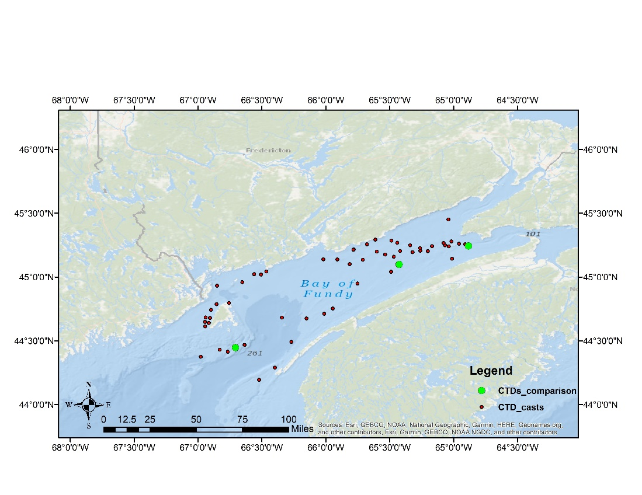

Cast 2

Cast 1

Cast 3

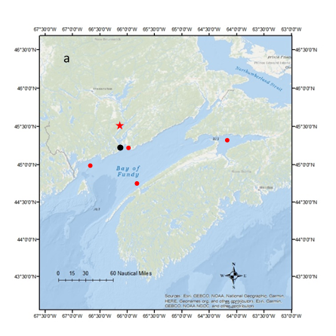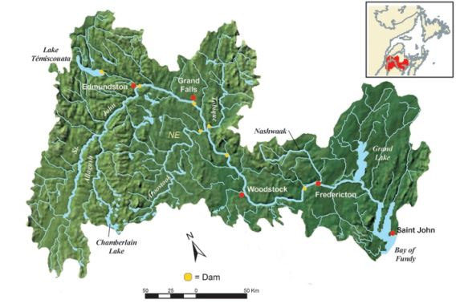

b

There has been a significant amount of research on the barotropic condition of Bay of Fundy using different model configuration such as the structured models [31,32]and unstructured ones, [33–36]. These models usually simulate the tidal and wind-derived variation of sea level and currents. Resolving the baroclinic condition of Bay improves the emergency response (oil spill) [21] and the transition between well-mixed and stratified zones which are important from a biological perspective [37,38]. However, A few studies focused on the baroclinic condition of Bay, mostly lower parts of Bay and Gulf of Maine. Watson [27], showed that the counter-clockwise gyre at the mouth of Bay is mostly driven by density effects while the tidal rectification and density-driven circulation [22] resulting from surface heating [39] and freshwater inflow [24] could be the driving factor together. Also, tidal current and coastal processes may be affected by variations of temperature and salinity resulting from the surface and open boundary heat and freshwater fluxes [40]. One contributing factor which increases the model skill is how good the model can resolve the dynamic processes on the ocean domain, and this comes from the mesh resolution on which the model is running. The oceanic process properties vary on many scales which are dependent on factors such as coastline, bottom topography variation, the forcing meteorology, changing Coriolis force with latitude and the Rossby radius of deformation [41]. Coastal models usually require increased spatial and temporal resolution to provide accurate forecasts [42,43] by capturing a wider energy spectrum in the model and improving our understanding of oceanic sub-mesoscale dynamics [44] such as capturing the freshwater front from river discharge [45] or an accurate representation of sea surface temperature [21]. However, this leads to an increase in computation time, the requirement for extra computer storage space, and decreasing the model time steps to satisfy the computational fluid dynamic stability condition (Courant-Friedrichs-Lewy, CFL) [41,45].

Knowledge of the baroclinic condition of the Bay can enhance acoustic hydrographic surveys by defining the areas of high sound speed variability for better time, cost and effort efficiency of the survey. Besides, by relying on the baroclinic condition of the domain, biological studies, for instance, habitat mapping, and retention of organisms such as phytoplankton [46], zooplankton [47], scallop larvae [19]which finally provide better insight for decision-makers to provide a sustainable plan for the marine environment.

In this model for the Bay of Fundy, we use a high-resolution mesh up to 10 meters to resolve the oceanographic condition of the Bay, specifically temperature and salinity, for two months in July and August 2018.

The paper is composed as follows. In section 2, we describe the model configuration, open boundary forcing, and initialization. Section 3 presents the model evaluation against Saint John River tide gauge data, Canadian Hydrographic Service (CHS) published constituents for the Bay of Fundy and CTD casts from fieldwork and the World Ocean Atlas Database. Section 4 presents the summary and conclusion.

**2 Methodology**

A high-resolution model has been developed for this study with the horizontal resolution from 20m to 6km. The domain covers the whole Bay of Fundy including Chignecto Bay and Minas Basin and upper part of Saint John River up to Evandale, New Brunswick. The following subsections explain the model configuration, parameters, and open boundary forcing,initialization, and surface forcing.

**2.1 Model configuration and parameters**

In this paper, we use Finite-Volume Community Ocean Model, FVCOM, which is originally developed by [48] and upgraded by the joint effort of University of Massachusetts Dartmouth (UMAS-D) and Woods Hole Oceanographic Institution (WHOI) [49]. The model uses an unstructured grid, 3D primitive equations and is embedded with different modules such as sediment transport, Global Ocean Turbulence Model (GOTM) [50], 3D Wet-Dry module, nesting module. The equations of momentum, continuity, temperature, salinity, and density in a spherical coordinate system with GOTM, k-ε, or MY-2.5 [51] turbulent mixing in the vertical and a Smagorinsky turbulent closure scheme in the horizontal [52] are used as governing equations in the model. In the horizontal, the governing equations are discretized in the flux form over the unstructured triangular mesh [48] and generalized terrain-following coordinate in the vertical [53]. To integrate in time, the model benefits from mode split and semi-implicit schemes, while it uses the second-order accurate advection scheme in space. Also, by using the unstructured grid and finite volume method the model benefits from the simple discrete computational efficiency from finite-difference and geometry flexibility from finite element methods and the accurate conservation of salt, heat, mass is provided by the flux computational method. The domain of the mesh configuration is shown in Fig. 3.with the two fine resolution spots in the Saint John River and Minas Passage at 20 m resolution .

The coastline dataset is extracted from Global Self-consistent, Hierarchical, High-resolution Geography Database (GSHHG) [54] with the full resolution. The model bathymetry is a 100-m resolution from CHS and Natural Recourses Canada (NRCan) and the areas which are not covered by this dataset, such as Chignecto Bay, the entrance of Passamaquoddy Bay, and close to Bear Cove, are digitized from chart numbers 4010, 4011, 4012, 4013, 4117, 4396. Part of the Saint John River is covered by CHS bathymetry data and the rest is from University of New Brunswick Ocean Mapping Group dataset [55](McNeill et al., 2018).

Figure 3.Unstructured mesh generated by SMS and location of two high resolution spots.

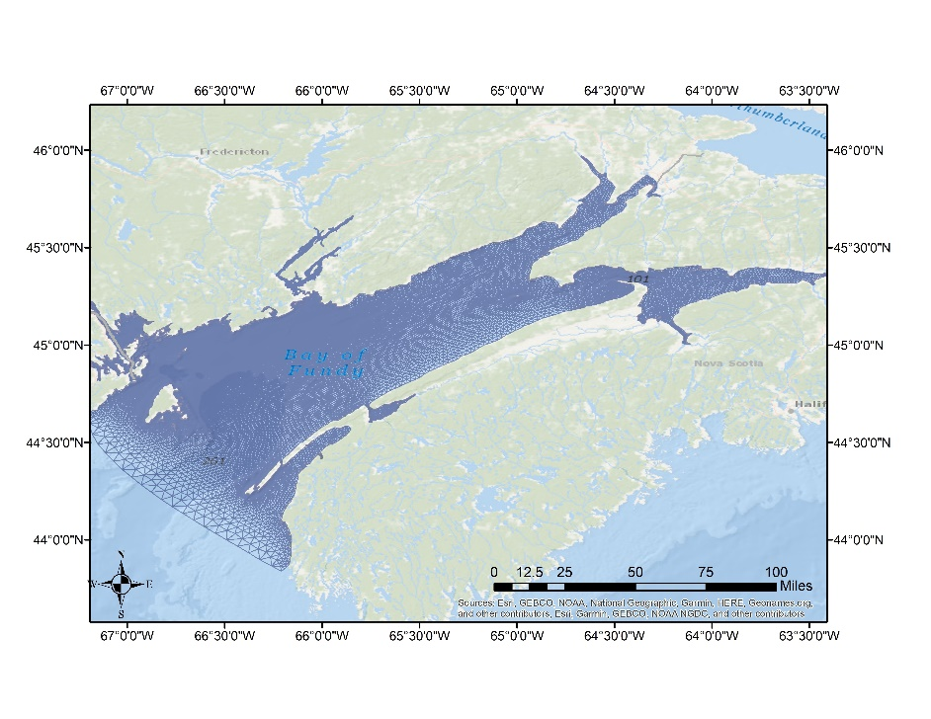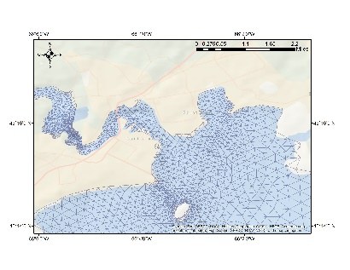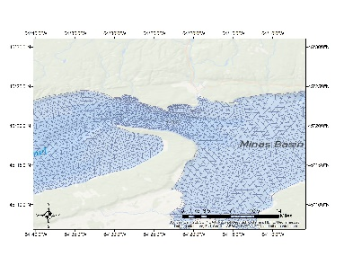

The mesh is generated by the Surface Water Modeling System (SMS 12.1) [56] which is commercial software for creating the unstructured grid with different modules (Map, Mesh, and Scatter) that are necessary for FVCOM. The mesh quality recommendation for FVCOM is as follows based on the FVCOM manual: The Minimum interior angle is 30 degrees, maximum interior angle of 130 degrees, the maximum slope 0.1, the Element area change 0.5, and the connecting elements 7. The total number of nodes and elements for the coarse and fine resolution are 34871, 64765 and 35649, 66321, respectively. The horizontal resolution ranges from 6km in the open boundary attached to the Gulf of Mine to 20 m in the Reversing Falls Saint John Rivera. In the vertical coordinate, 40 uniform sigma layers have been applied.

For time integration, the mode-split scheme is used to separate the time step between the internal (baroclinic) and external (barotropic) mode. The time steps for a barotropic run for internal and external mode is set to 0.5 s, and for baroclinic run 0.3 s and MY-2.5 is used as vertical turbulence closure to parametrize the vertical eddy viscosity and the vertical thermal diffusion coefficient [49]. Spatially constant values for the minimum bottom roughness have been examined and the results are provided in section 3.1.

**2.2 Model initialization and open boundary forcing**

The model consists of two open boundaries, one in the upper part of Saint John River with 3 nodes and the other one is adjacent to the Gulf of Maine with 23 nodes. The surface temperature and river water level are from Environment and Climate Change Canada. The small open boundary is considered close to the Evandale area and the river water level is from the Oak station (01AP003). By using this boundary location, we can assume that we have the freshwater inflow at that point (O’Flaherty-Sproul and Haigh, pers.comm). At the main open boundary, the forcing includes tidal elevation, temperature, and salinity. The tidal elevation, with five main constituents for the Bay (M2, N2, S2, K1, and O1), is extracted from an unstructured barotropic tidal model, the WebTide Scotia - Fundy - Maine model, which is tuned for the Bay of Fundy [34].To facilitate the tuning process of tides in the Bay, we just considered the five constituents which in total need 27 days of simulation data to perform the tidal analysis. 6-hourly time series of temperature and salinity for the open boundary are extracted from Gulf of Maine Operational Forecast System(GoMOFS) [57] which use ROMs(Regional Ocean Model system) with 700 m horizontal resolution and 30 vertical level, is running operationally on NOAA’s High Performance Computer Sysytems(HPCS) predicting the water level, currents, water temperature, and salinity for 72 hours for each cycle. Also, the initialization of currents, temperature, and salinity are extracted from GoMOFS for the start of simulation The model is set to run in ‘hot-start’ from 1st July to 1st September 2018, with 10 hours spin up. The model’s sea surface is forced with hourly data including specific humidity,2-m air temperature, surface incoming longwave and shortwave radiation, and 10-m wind from the High-Resolution Deterministic Prediction System(HRDPS) [58]at 2.5 km resolution which is running operationally at the Canadian Center for Meteorological and Environment Prediction(CCMEP).

**3 Evaluation of tide and water properties**

In this section, we provide an evaluation of the model to represent the dominant features of the oceanographic conditions of the Bay. Figure 2 shows the location of CTD casts from fieldwork and the World Ocean Atlas Database during the simulation period. We evaluate the model base on the (1) tide and (2) residual currents and (3) variation in temperature and salinity.

**3.1 Tidal constituents**

The observations of water level in the Saint John Harbour is from the tide gauge located in Figure 1a. The model run period is July and August of 2018, however, there are gaps in the tide gauge data, and we compared the data from July 19th to August 27th and the result are in Figure 4.The simulated sea water level has a good agreement in phase with the tide gauge data and less than 0.6 m difference in amplitude which may result from not including all constituents and wind surge. The tide gauge data is vertically referenced to the chart datum while the water level in FVCOM is relative to the mean sea level (MSL)

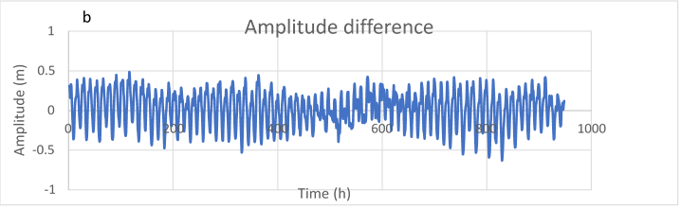

Figure 4..a) Comparison between tide gauge with simulated water level, and b) the difference between them. Time is hourly since 19th July until 27th August.

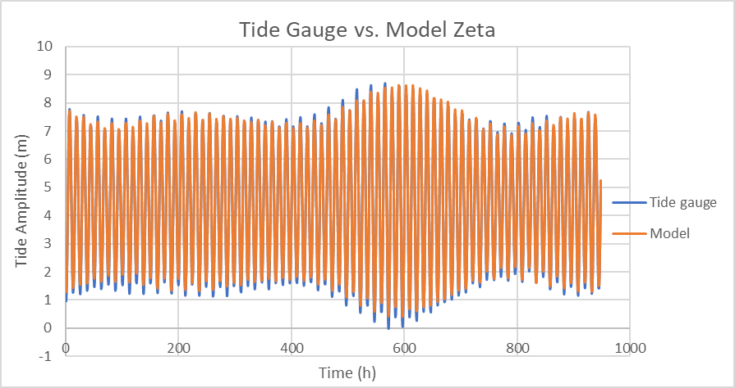

a

; therefore, the Canadian Continuous Vertical Datum Hydrographic Vertical Separation (HyVSEP) solution (CANEAST2015v1CL) [59] was used to relate MSL and chart datum.The model was run with different values of the bottom roughness coefficient to evaluate which value provides a better representation of tidal propagation for the domain. A harmonic analysis [60] is performed on the simulated water level with different bottom roughness coefficients to determine the best value with the smallest error for the whole bay and the results are compared with the CHS(Canadian Hydrographic Society) tidal constituents in the table 1, 2, and 3. The error metric is the distance in the complex plane between observed (CHS constituents) and modeled constituents [34] and is defined as follow:

$E= \left|A_{0}e^{i∅_{0}}- A_{m}e^{i∅_{m}}\right|$ (1)

where $A_{0}$, $∅_{0}$ are the amplitude and phase of the observed harmonic and $A_{m}$, $∅_{m}$ are the amplitude and phase of the modeled harmonic. We use this metric which combines the amplitude and phase errors in a single number for the validation.

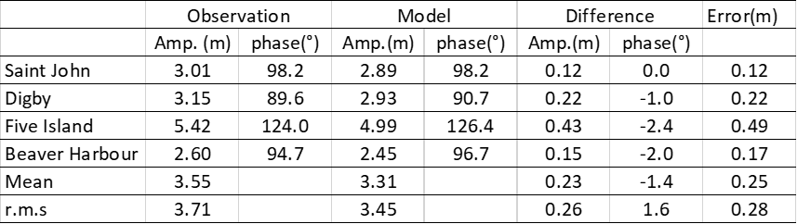

Table 1.CHS and modelled amplitude(m) and phase (degree, GMT) and discrepancies(CHS-Model) for M2 with bottom coefficient 0.015.The error is from the metric in equation 1

Table 2.CHS and modelled amplitude(m) and phase (degree, GMT) and discrepancies(CHS-Model) for M2 with bottom coefficient 0.007.The error is from the metric in equation 1

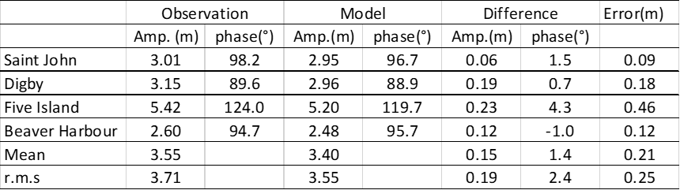

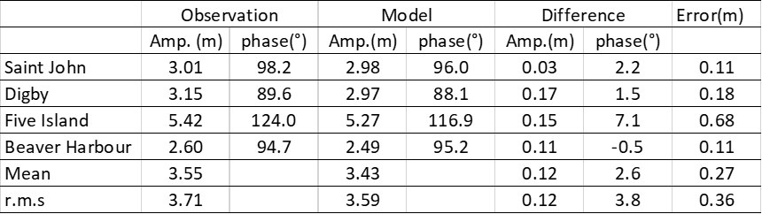

Table 3.CHS and modelled amplitude(m) and phase (degree, GMT) and discrepancies(CHS-Model) for M2 with bottom coefficient 0.005.The error is from the metric in equation 1

The r.m.s value for the M2 constituent in all four stations (Fig. 1a) with different bottom coefficient are presented in the Table 1, Table 2 and Table 3. The predicted tide by the model for Five Island and Saint John Harbour have the highest and smallest error, respectively and the minimum mean and r.m.s error results from using a bottom roughness coefficient equal to 0.007.

The validation for all five constituents against the CHS constituents is shown in Fig. 5. In total, M2, K1, O1 and N2 phases from the model tend to be larger than the CHS ones with smaller model predicted amplitude for M2 and S2 and a larger amplitude for N2. The modelled M2 constituent is close to the CHS with amplitude errors generally between 0.06 to 0.22 m and with the highest error in phase in the Five Island point which lags by about 5.1 degrees. The errors in the N2 phase range from 3.3 to 14.9 degrees while the amplitude errors are less than 0.11 m.

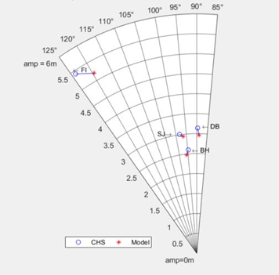

a

M2

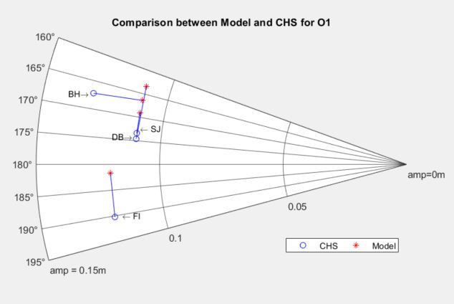

e

**O**1

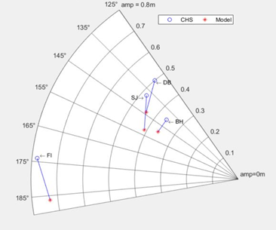

c

**S**2

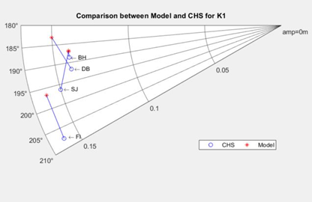

d

**K**1

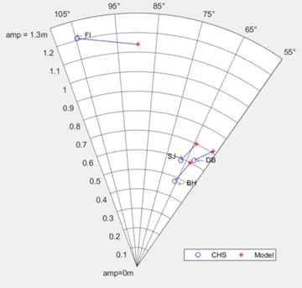

b

N2

The S2 is the only constituent that has a late phase between 9.1 and 20.3 degrees with a small amplitude error of less than 0.06 m. With phase errors between 1.8 and 10 degrees and amplitude errors of less than 0.01 m, K1 is one of the model constituents which is ahead of CHS one. Finally, O1 with no special pattern has an amplitude error of less than 0.02m and phase error of 0.7 to 11 degrees.

For all three bottom roughness coefficients, it seems that the phase has more impact on the error calculation than amplitude. The comparison for M2, between our model output with 0.007 as the bottom coefficient and the WebTide model, is provided in Fig.6.

Figure 6.The Amplitude(colour shading, in m) and phase(contours, in degree, GMT) of sea level for the principal lunar semidiurnal tidal constituent(M2) a) WebTide , b)Bottom Coefficient 0.005, c) Bottom Coefficient 0.007, d) Bottom Coefficient 0.015

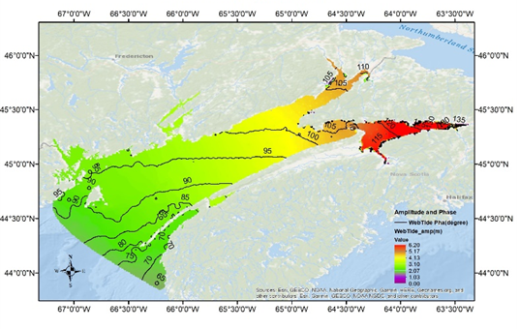

a

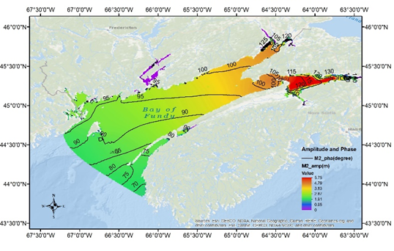

b

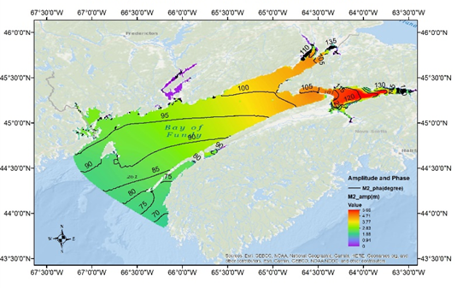

c

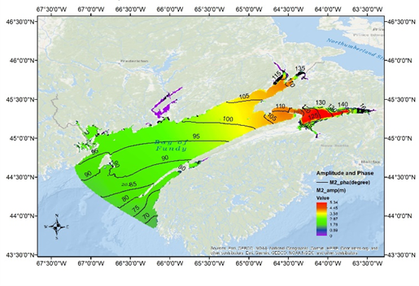

d

The phase pattern is following the WebTide very closely and there is a maximum amplitude difference of 40 cm in the Minas Passage. These discrepancies may come from the model forcing which is not included in the model run or using a constant bottom roughness which can impact the representation and accuracy of tidal solutions [21]. By decreasing the bottom coefficient to 0.005, the water body feels less friction from the seabed and the model phase surpasses the Webtide phase (Fig. 6b), while when we increase the coefficient to 0.015, it feels more friction and the phase lags behind the WebTide phase (Fig. 6d). With the coefficient equal to 0.007, we have the best fit for our model phase (Fig. 6c). The finer mesh resolution can potentially improve model skill and the comparison with a coarse resolution (RIOPS) is shown in table 4 for the three main constituents in the Saint John Harbour; M2, N2, and S2 with an amplitude of 3.01, 0.60, and 0.49 m, respectively. The M2 amplitude improves as the resolution increase from RIOPS to FVCOM with a 10% error (33cm) to 1.9% error (6cm), respectively. The tidal constituents for RIOPS is from [21].

Table 4.Comparison of tidal amplitude and phase of water level for M2 at Saint John River tide gauge, WebTide, RIOPS, and FVCOM

**3.5 Tidal Residuals**

The residual flows can result from different factors, for instance, nonlinear interaction between tides, bottom topography, the geometry of the coastline, bottom friction, winds, waves, density variations and far-field general circulation [35]. We compare the residuals form each model runs, Barotropic and Baroclinic. By analyzing current meter data, Bigelow [15]showed that there is an anticlockwise gyre near Cape split due to strong mean inward and outward flow, and further analysis of these observations by Tee [61,62] revealed three other gyres, one clockwise gyre in Minas Channel, and two gyrs in the Minas Passage on the west(clockwise) and east(anticlockwise) side and last one(clockwise) off Cape Blomidon [8,35]), Fig. 7, Fig. 8, and Fig. 9 ,respectively.

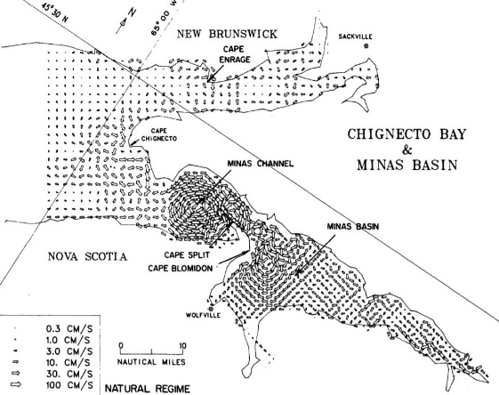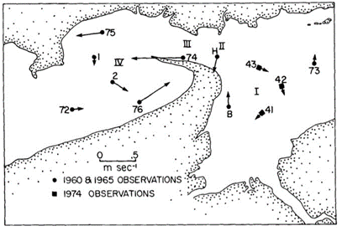

Figure 7. The observed residual currents in the Minas area (from Tee, 1977)

Figure 8. The residual currents in the Minas Basin and channel (from Greenberg, 1982)

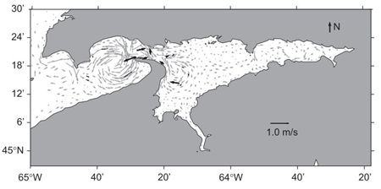

Figure 9. The depth-averaged residual flow (from Wu et al, 2011)

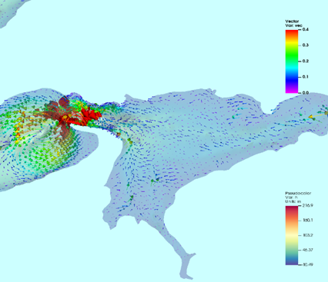

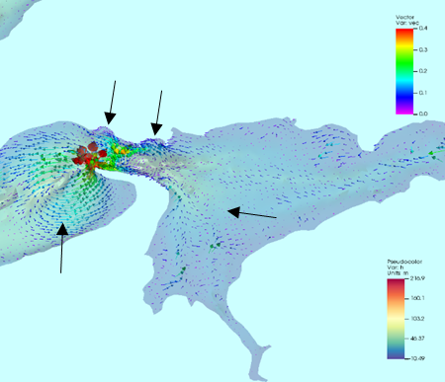

a

b

Figure 10.Tidal residual currents in the Minas Basin area and location of four gyres in (a)Barotropic run and (b) Baroclinic run

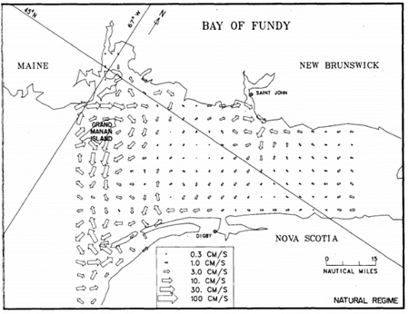The residual flow for the barotropic run is presented in Fig. 10a at the end of the simulation period, August 31st. The high-resolution grid in the model, especially in the Minas Passage and Channel, can resolve these features. It seems that the tide, complex geometry at the entrance of Minas Passage result in the generation of the gyres. There is an improvement for the residual currents in the Baroclinic run (Fig. 10b) and it shows that in the Minas Basin area, the shape of the gyre persists but the residual currents speed increase due to baroclinic effect. In the lower part of Bay, northeast of Grand Manan Island, the baroclinic effect has generated a clockwise gyre around the high gradient depth area (Fig. 12). In the lower part of Bay, northeast of Grand Manan Island, the baroclinic effect has generated a clockwise gyre around the high gradient depth area The same residual current(Fig.11) has been resolved at the entrance of the Bay [63,64].

Figure 11.Residual currents at the Bay entrance and Grand Manan Island (from Greenberg, 1982).

Figure 12.The tidal residual currents at entrance of the Bay for(a)Barotropic and (b) Baroclinic run

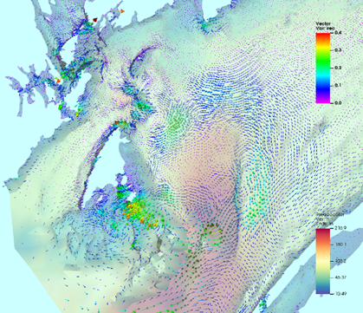

b

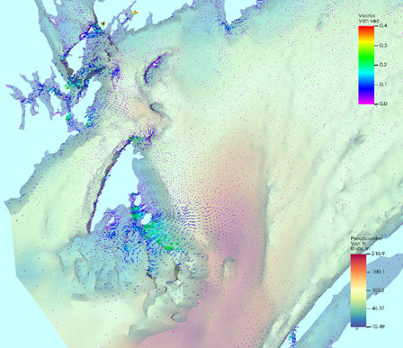

a

**3.4 Temperature and salinity variability**

**3.4.1 Temperature and salinity profile**

The temperature and salinity are evaluated against a set of 58 CTD casts from field and World Ocean Database [65]in July and August 2018 (Fig. 2). Three different spots comparison between CTD casts and model output are demonstrated in the Figure 13, one at the Bay entrance, the other in the middle of the Bay, and the last one at the head of the Bay (Casts are numbered in the Fig.2). More statistical analysis on the model output are provided in the model skill assessment section.

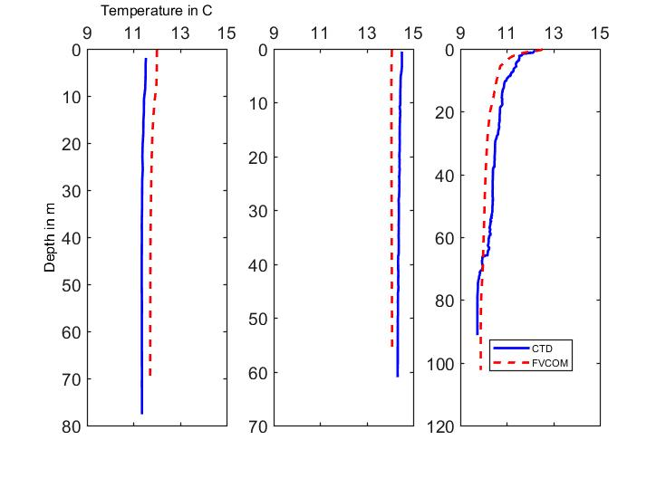

Temperature in C

Cast 1

Cast 2

Cast 3

**a**

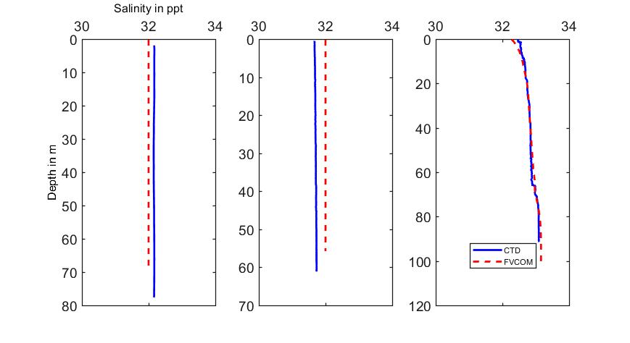

Salinity in ppt

**b**

Cast 1

Cast 2

Cast 3

Figure 13.Comparison between CTD cast and Model output for a) temperature and b) salinity for three locations in green circles in Fig.2, cast 1,2,3

Both temperature and salinity follow the CTD cast pattern and have a good agreement with the observations.

**3.4.2 Sea Surface Temperature**

Another method to validate the model output is to compare the sea surface temperature against the satellite derived SST. The level 4 SST analysis here is provided by the Group of High-Resolution Sea Surface Temperature (GHRSST) , produced by the JPL OurOcean group which use different satellite and in situ data from drifting and moored buoys to form the sea surface foundation temperature with daily temporal and 0.01 degree spatial resolution(G1SST,Global 1km Sea Surface Temperature). The surface temperature in GHRSS is called the foundation temperature which is a temperature free of diurnal temperature variability. The result of difference between G1SST and the SST from model are illustrated in the Fig. 14 for three days on 15 Jul., 30 Jul., and 30 Aug. 2018.At the mid-July, the model tends to be a little warm with some cold spots in the middle of the Bay and close to the Grand Manan Island. The cold spot in front of the Saint John River may result from not having the temperature profile of the river to use for the open boundary. At the end of July, the cold area increase, specifically in front of Saint John River and at the end of August the difference decreases except the north-east of Grand Manan Island.

Figure 14.Results of daily SST difference from G1SST minus Model output for a)20180715, b)20180730, and c)20180830

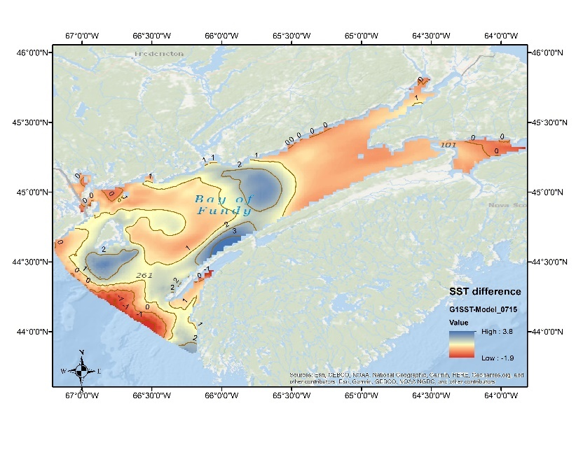

a

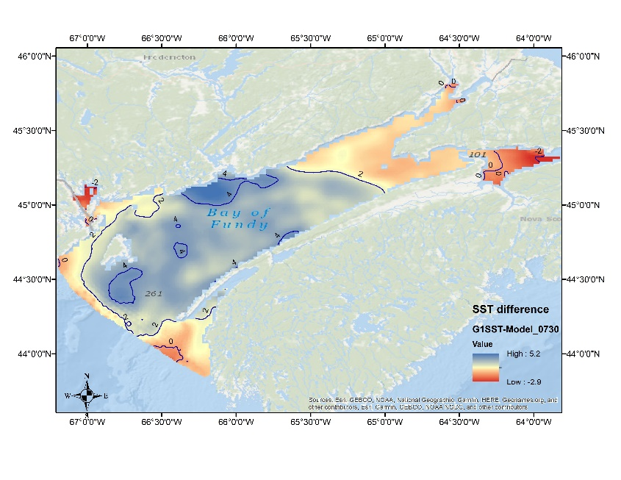

b

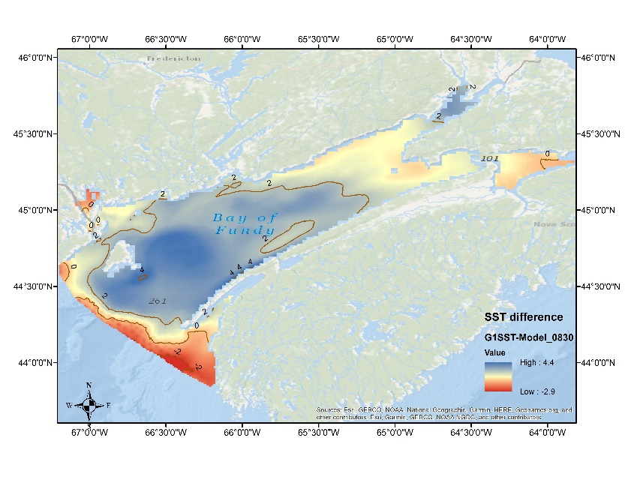

c

At the open boundary, the temperature which is from Gulf of Maine Operational Forecast System is slightly higher than G1SST data showing a warm front on that area. In total, by keeping the definition of foundation temperature in mind, the model SST dose no show a significant difference with the satellite derived one. In next section, the break down of statistical analysis provide better metrics for the model skill assessment.

**4. Model skill Assessment**

Depending on the different specific factors, such as goals of the modeling exercise, spatial and temporal importance of the context, the model skill definition is subject to change. Generally, the skill means how well the model represent the truth over a specific range of condition ,however, we compare the model output against the observations (having a range of uncertainty in both) since we cannot measure the truth[66].We have done the visual comparison for the temperature and salinity in the pervious sections. A quantitative technique is provided to find out the reliability of the model simulation. These are the quantitative metrics to assess the model skill based on the pairs of model-observations [67].

1. r: The correlation coefficient of the model predictions and observations:


2. RMSE: the root mean squared error:


3. RI: the reliability index:


4. AE: the average error(bias)


5. AAE: the average absolute error:


6. MEF: the modeling efficiency



Where n = the number of observations, Oi = the ith of n observations, Pi = the ith of n prediction, and and are the observation and prediction averages, respectively.

The tendency of the observed and predicted values to vary together is measured by the r, the correlation coefficient which range from -1 to 1 and ideally this value will be close to one however, they could differ by a consistent values while having the r close to one.

The size of discrepancies between observation and prediction are measured by the root mean squared (RMSE), average error (AE), and average absolute error (AAE) and values near to zero are ideal. The AE is a measure of aggregate model bias and AAE and RMSE consider the magnitude of each discrepancy rather than the direction (AE).

The average factor by which the model predictions differ from observation is calculated by the RI [68] which ideally should be close to one.

Finally, The MEF measure the model efficiency on how well it predicts relative to the average of the observations [69,70] and a the ideal value of one shows a close match between model prediction and observation, while a value close to zeros indicate that the model cannot predict each observation not better than the average of observations and values less than zero it is better to use the average of the observation than the model prediction.

I defined three levels for CTD profile, surface, middle layer, and bottom layer and measured the model skill to show how well the model can predict the values in each of these layers in comparison to the observations. The results are provided in the table 5.

Table 5.The result of Model skill assessment using the CTD casts for temperature and salinity

|  |  |  |  |  |  |  |  |  |  |  |
| --- | --- | --- | --- | --- | --- | --- | --- | --- | --- | --- |
|  | layer | r | RMSE | | RI | AE | AEE | Variance (CTD) | Std(CTD) | MEF |
| Temperature | Surface | 0.90 | 0.59 | 1.02 | | -0.29 | 0.47 | 1.43 | 1.19 | 0.75 |
| Middle | 0.96 | 0.42 | 1.01 | | -0.11 | 0.35 | 2.23 | 1.49 | 0.92 |
| Bottom | 0.96 | 0.44 | 1.01 | | -1.01 | 0.36 | 2.59 | 1.61 | 0.92 |
|  |  |  |  |  | |  |  |  |  |  |
| Salinity | Surface | 0.66 | 0.19 | 1.00 | | -0.01 | 0.15 | 0.06 | 0.26 | 0.44 |
| Middle | 0.88 | 0.21 | 1.00 | | -0.02 | 0.18 | 0.17 | 0.41 | 0.74 |
| Bottom | 0.91 | 0.22 | 1.00 | | -0.05 | 0.19 | 0.24 | 0.49 | 0.79 |

There is a high correlation between model prediction and observation values for temperature in all three layers, while the RMSE, AE, and AEE are all small in comparison to the variability of observations. The RI is close to one which show a good model reliability and a fairly close MEF, especially for the middle layer and bottom. The model shows significantly better skills in temperature prediction for the middle and bottom layer than surface. For Salinity, the correlation values are a little smaller than temperature, especially at the surface, but the RMSE, AE, and AEE are relatively small .However, the salinity variability is not as high as temperature which lead to the lower values of MEF while the model prediction provides better skills for salinity at the bottom and middle layer than surface. The MEF is function of RMSE and the variance of observations according to which S2 represents the variance of observations. In the case of salinity, all layers have almost the same RMSE close to 0.20 while there is a significant difference in their CTD variance at 0.06, 0.17, and 0.24 at the surface, middle, and bottom layer, respectively. Also, lower values of std at the surface in comparison to the middle and bottom layer indicate that the surface layer is more homogeneous. Also, the variance of salinity is much smaller than salinity and a small AEE can reduce the MEF.

**4 Summary**

In this work, a three-dimensional coastal ocean model is developed based on the FVCOM. The model is configured to run in baroclinic mode by including the temperature and salinity, tidal level, and Saint John River water level. A high-resolution mesh was generated to resolve the complex geometry of the lower Saint John River to capture the freshwater plume discharge [45] to the Bay. The tidal level extracted from the tidal model, WebTide Scotia - Fundy - Maine, and temperature and salinity from an operational model in the area, GoMOFS. The model is assessed using observational data, including temperature and salinity from CTD casts, and the published tidal constituents for sea level. The model was able to predict the tide with good accuracy in Saint John Harbour, underestimating the amplitude and phase by no more than 6 cm and 1.5° for M2, 10cm and 2° for N2, and 6cm and 15° for S2. The average error for the four stations in the Bay is about 21cm and 2.1°. In the Minas Basin area, the model had the largest M2 error of 45cm which may result from using a constant bottom roughness for the whole Bay. It may be useful to increase the bottom roughness coefficient in the Minas Passage and in the Reversing Falls to improve the tidal level representation. By increasing the resolution in Minas Passage and channel, the model resolved all four gyres in that area. Also, the result of the baroclinic run showed an increase in the speed of residual currents while conserving the gyre shapes, as compared to the barotropic run. A clear clockwise residual current was generated to the northeast of Grand Manan Island on the bottom, however, the barotropic run did not generate any clockwise residual flow in that area. In the Bay of Fundy, salinity is a dominant factor in the variation of density structure and by increasing the resolution in Saint John River area, which is the main source of freshwater discharge in the Bay, the Model could capture the outflow of the river which flows on the surface close to the New Brunswick side extending to Grand Manan Island. A comparison of the model data against the CTD data showed that the model could provide better skills at the middle and bottom layers for both temperature and salinity while the skills are in favour of temperature which may resulted from the lack of temperature and salinity profile for the Saint John River which is the main contribution of fresh water to the Bay and also the resolution of surface forcing and whether it is reanalysis or not, and the specification of the river discharge to the Bay affect the temperature and salinity in the water column. This assumption needs more analysis to find out the effect of different spaciotemporal surface forcing resolution on the predicted tracer values.

We acknowledge the use of imagery from the NASA Worldview application ([https://worldview.earthdata.nasa.gov](https://worldview.earthdata.nasa.gov/" \t "_blank)), part of the NASA Earth Observing System Data and Information System (EOSDIS).The G1SST product are available from PoDAAC/JPl (https://podaac.jpl.nasa.gov/dataset/JPL\_OUROCEAN-L4UHfnd-GLOB-G1SST)

1. Worm, B.; Barbier, E.; Beaumont, N.; Duffy, J.; Folke, C.; Halpern, B.; Jackson, J.; Lotze, H.; Micheli, F.; Palumbi, S.; et al. Impacts of Biodiversity Loss on Ocean Ecosystem Services. *Science* **2006**, *314*, 787–790, doi:10.1126/science.1132294.

2. Brown, C.J.; Smith, S.J.; Lawton, P.; Anderson, J.T. Benthic habitat mapping: A review of progress towards improved understanding of the spatial ecology of the seafloor using acoustic techniques. *Estuar. Coast. Shelf Sci.* **2011**, *92*, 502–520, doi:10.1016/j.ecss.2011.02.007.

3. Anderson, J.T.; Van Holliday, D.; Kloser, R.; Reid, D.G.; Simard, Y. Acoustic seabed classification: Current practice and future directions. *ICES J. Mar. Sci.* **2008**, *65*, 1004–1011, doi:10.1093/icesjms/fsn061.

4. Shaw, J.; Amos, C.L.; Greenberg, D.A.; O’Reilly, C.T.; Parrott, D.R.; Patton, E. Catastrophic tidal expansion in the Bay of Fundy, CanadaEarth Sciences Sector (ESS) Contribution 20090423. *Can. J. Earth Sci.* **2010**, *47*, 1079–1091, doi:10.1139/E10-046.

5. Li, Y.; Fratantoni, P.S.; Chen, C.; Hare, J.A.; Sun, Y.; Beardsley, R.C.; Ji, R. Spatio-temporal patterns of stratification on the Northwest Atlantic shelf. *Prog. Oceanogr.* **2015**, *134*, 123–137, doi:https://doi.org/10.1016/j.pocean.2015.01.003.

6. Swift, D.J.P.; Pelletier, B.R.; Lyall, A.K.; Miller, J.A. Sediments of the Bay of Fundy - A Preliminary Report. *Atl. Geol.* **1969**, *5*, doi:10.4138/1801.

7. GARRETT, C. Tidal Resonance in the Bay of Fundy and Gulf of Maine. *Nature* **1972**, *238*, 441–443, doi:10.1038/238441a0.

8. Greenberg, D.A. Modelling the Mean Barotropic Circulation in the Bay of Fundy and Gulf of Maine. *J. Phys. Oceanogr.* 1983, *13*, 886–904.

9. Desplanque, C.; Mossman, D.J. Bay of Fundy Tides. *Geosci. Canada* **2001**, *28*.

10. Redfield, A.C. Interference phenomena in the tides of the Woods Hole region. *J. Mar. Res.* **1953**, *12*, 121–140.

11. Percy, J.A.; Wells, P.G.; Evans, A.J. Bay of Fundy issues: A scientific overview. *Environ. Canada - Atl. Reg. Occas. Rep. No. 8* **1997**, *8*.

12. Li, M.Z.; Hannah, C.G.; Perrie, W.A.; Tang, C.C.L.; Prescott, R.H.; Greenberg, D.A. Modelling seabed shear stress , sediment mobility , and sediment transport in the Bay of Fundy 1. **2015**, *775*, 757–775.

13. Xue, H.; Chai, F.; Pettigrew, N.R. A model study of the seasonal circulation in the Gulf of Maine. *J. Phys. Oceanogr.* **2000**, *30*, 1111–1135, doi:10.1175/1520-0485(2000)030<1111:AMSOTS>2.0.CO;2.

14. Bailey, W.B.; MacGregor, D.G.; Hachey, H.B. Annual Variations of Temperature and Salinity in the Bay of Fundy. *J. Fish. Res. Board Canada* **1954**, *11*, 32–47, doi:10.1139/f54-005.

15. Bigelow, H.B. Dynamic oceanography of the Gulf of Maine. *Eos, Trans. Am. Geophys. Union* **1927**, *8*, 206–211, doi:10.1029/TR008i001p00206.

16. Godin, G. The 1965 current survey of the Bay of Fundy. *A new Anal. data an Interpret. results* **1968**.

17. Brooks, D.A. A brief overview of the physical oceanography of the Gulf of Maine. *Proc. Gulf Maine Sci. Work.* **1992**, 51–74.

18. Hachey, H.B.; Bailey, W.B. The general circulation of the waters of Bay of Fundy. *Gen. Ser. Circ. Fish. Res. Board Can., Biol. Sin.* **1952**, 10.

19. Dickie, L.M. Fluctuations in abundance of the giant scallop, Placopecten magellanicus (Gmelin), in the Digby area of the Bay of Fundy. *J. Fish. Res. Board Canada* **1955**, *12*, 797–857.

20. Cunjak, R.A.; Newbury, R.W. Atlantic coast rivers of Canada, Chapter 21, pp. 939-980. *Rivers North Am.* **2005**, 1144.

21. Paquin, J.P.; Lu, Y.; Taylor, S.; Blanken, H.; Marcotte, G.; Hu, X.; Zhai, L.; Higginson, S.; Nudds, S.; Chanut, J.; et al. High-resolution modelling of a coastal harbour in the presence of strong tides and significant river runoff. *Ocean Dyn.* **2020**, *70*, 365–385, doi:10.1007/s10236-019-01334-7.

22. Aretxabaleta, A.L.; McGillicuddy, D.J.; Smith, K.W.; Lynch, D.R. Model simulations of the Bay of Fundy Gyre: 1. Climatological results. *J. Geophys. Res. Ocean.* **2008**, *113*, 1–16, doi:10.1029/2007JC004480.

23. Chao, S.Y.; Boicourt, W.C. Onset of estuarine plumes. *J. PHYS. Ocean.* **1986**, *16*, 2137–2149, doi:10.1175/1520-0485(1986)016<2137:ooep>2.0.co;2.

24. Brooks, D.A. A model study of the buoyancy-driven circulation in the Gulf of Maine. *J. Phys. Oceanogr.* **1994**, *24*, 2387–2412, doi:10.1175/1520-0485(1994)024<2387:AMSOTB>2.0.CO;2.

25. Brooks, D.A.; Townsend, D.W. Variability of the coastal current and nutrient pathways in the eastern Gulf of Maine. *J. Mar. Res.* **1989**, *47*, 303–321, doi:10.1357/002224089785076299.

26. Lynch, D.R.; Holboke, M.J.; Naimie, C.E. The Maine coastal current: Spring climatological circulation. *Cont. Shelf Res.* **1997**, *17*, 605–634, doi:10.1016/S0278-4343(96)00055-6.

27. Watson, E.E. Mixing and residual currents in the tidal waters as illustrated in the Bay of Fundy. *J. Biol. Board Can* **1936**, *2*, 141–208.

28. Aretxabaleta, A.L.; McGillicuddy, D.J.; Smith, K.W.; Manning, J.P.; Lynch, D.R. Model simulations of the bay of fundy gyre: 2. Hindcasts for 2005-2007 reveal interannual variability in retentiveness. *J. Geophys. Res. Ocean.* **2009**, *114*, doi:10.1029/2008JC004948.

29. Apollonio, S. The Gulf of Maine. *Gulf Maine* **1979**.

30. Pettigrew, N.R.; Townsend, D.W.; Xue, H.; Wallinga, J.P.; Brickley, P.J.; Hetland, R.D. Observations of the Eastern Maine Coastal Current and its offshore extensions in 1994. *J. Geophys. Res. Ocean.* **1998**, *103*, 30623–30639, doi:10.1029/98jc01625.

31. Greenberg, D.A. A numerical model investigation of tidal phenomena in the bay of fundy and gulf of maine. *Mar. Geod.* **1979**, *2*, 161–187, doi:10.1080/15210607909379345.

32. Sankaranarayanan, S.; McCay, D.F. Three-dimensional modeling of tidal circulation in Bay of Fundy. *J. Waterw. Port, Coast. Ocean Eng.* **2003**, *129*, 114–123, doi:10.1061/(ASCE)0733-950X(2003)129:3(114).

33. Dupont, F.; Hannah, C.G.; Greenberg, D. Modelling the Sea Level of the Upper Bay of Fundy. **2005**, *43*, 33–47.

34. Dupont, F.; Hannah, C.G.; Greenberg, D. Modelling the sea level of the upper Bay of Fundy. *Atmos. - Ocean* **2005**, *43*, 33–47, doi:10.3137/ao.430103.

35. Wu, Y.; Chaffey, J.; Greenberg, D.A.; Colbo, K.; Smith, P.C. Tidally-induced sediment transport patterns in the upper Bay of Fundy: A numerical study. *Cont. Shelf Res.* **2011**, *31*, 2041–2053, doi:10.1016/j.csr.2011.10.009.

36. Wu, Y.; Chaffey, J.; Law, B.; Greenberg, D.A.; Drozdowski, A.; Page, F.; Haigh, S. A CCESS A three-dimensional hydrodynamic model for aquaculture : a case study in the Bay of Fundy. **2014**, doi:10.3354/aei00108.

37. Pingree, R.D. The advance and retreat of the thermocline on the continental shelf. *J. Mar. Biol. Assoc. United Kingdom* **1975**, *55*, 965–974, doi:10.1017/S0025315400017859.

38. Denman, K.; Herman, A. Space-time structure of a continental shelf ecosystem measured by a towed porpoising vehicle. *J. Mar. Res.* **1978**, *36*, 693–714.

39. Garrett, C.J.R.; Keeley, J.R.; Greenberg, D.A. Tidal mixing versus thermal stratification in the bay of fundy and gulf of maine. *Atmos. - Ocean* **1978**, *16*, 403–423, doi:10.1080/07055900.1978.9649046.

40. Katavouta, A.; Thompson, K.R. Downscaling ocean conditions with application to the Gulf of Maine , Scotian Shelf and adjacent deep ocean. **2016**, *104*, 54–72, doi:10.1016/j.ocemod.2016.05.007.

41. Greenberg, D.A.; Dupont, F.; Lyard, F.H.; Lynch, D.R.; Werner, F.E. Resolution issues in numerical models of oceanic and coastal circulation. *Cont. Shelf Res.* **2007**, *27*, 1317–1343, doi:10.1016/j.csr.2007.01.023.

42. Garvine, R.W. A dynamical system for classifying buoyant coastal discharges. *Cont. Shelf Res.* **1995**, *15*, 1585–1596, doi:10.1016/0278-4343(94)00065-U.

43. Chant, R.J. Interactions between estuaries and coasts: river plumes - their formation, transport, and dispersal. *Treatise Estuar. Coast. Sci.* **2011**, *2*.

44. Soufflet, Y.; Marchesiello, P.; Lemarié, F.; Jouanno, J.; Capet, X.; Debreu, L.; Benshila, R. On effective resolution in ocean models. *Ocean Model.* **2015**.

45. Bricheno, L.M.; Wolf, J.M.; Brown, J.M. Impacts of high resolution model downscaling in coastal regions. *Cont. Shelf Res.* **2014**, *87*, 7–16, doi:10.1016/j.csr.2013.11.007.

46. Gran, H.H.; Braarud, T. A quantitative study of the phytoplankton in the Bay of Fundy and the Gulf of Maine (including observations on hydrography, chemistry and turbidity). *J. Biol. Board Canada* **1935**, *1*, 279–467.

47. Fish, C.J.; Johnson, M.W. The biology of the zooplankton population in the Bay of Fundy and Gulf of Maine with special reference to production and distribution. *J. Biol. Board Can.* **1937**, *3*, 189–322.

48. Chen, C.; Liu, H.; Beardsley, R.C. An unstructured grid, finite-volume, three-dimensional, primitive equations ocean model: Application to coastal ocean and estuaries. *J. Atmos. Ocean. Technol.* **2003**, *20*, 159–186, doi:10.1175/1520-0426(2003)020<0159:AUGFVT>2.0.CO;2.

49. Chen, C.; Beardsley, R.C.; Cowles, G. An unstructured grid, finite-volume coastal ocean model: FVCOM user manual. *An Unstructured Grid, Finite-volume Coast. Ocean Model FVCOM User Man.* **2006**.

50. Burchard, H. Applied turbulence modelling in marine waters. *Appl. Turbul. Model. Mar. Waters* **2002**.

51. Mellor, G.L.; Yamada, T. Development of a turbulence closure model for geophysical fluid problems. *Rev. Geophys.* **1982**, *20*, 851–875, doi:10.1029/RG020i004p00851.

52. Smagorinsky, J. General circulation experiments with the primitive equations. *Mon. Weather Rev.* **1963**, *91*, 99–164.

53. Pietrzak, J.; Jakobson, J.B.; Burchard, H.; Jacob Vested, H.; Petersen, O. A three-dimensional hydrostatic model for coastal and ocean modelling using a generalised topography following co-ordinate system. *Ocean Model.* **2002**, *4*, 173–205, doi:10.1016/S1463-5003(01)00016-6.

54. Wessel, P.; Smith, W.H.F. A global, self-consistent, hierarchical, high-resolution shoreline database. *J. Geophys. Res. B Solid Earth* **1996**, *101*, 8741–8743, doi:10.1029/96jb00104.

55. McNeill, P. (Universit. of N.; Church, I. (Universit. of N.; Leger, M. (Universit. of N. Integrating Bathymetric Datasets in the Lower Saint John River to produce a Common Reference Surface. In Proceedings of the Integrating Bathymetric Datasets in the Lower Saint John River to produce a Common Reference Surface; Canadian Hydrographic Conference: Victoria, 2018.

56. Surface-Water Modeling System, Version 11.0, Reference Manual & Tutorials, Aquaveo, L. SMS 2012.

57. Yang, Z.; Richardson, P.; Chen, Y.; Kelley, J.G.W.; Myers, E.; Aikman, F.; Peng, M.; Zhang, A. Model development and hindcast simulations of NOAA’s Gulf of Maine operational forecast system. *J. Mar. Sci. Eng.* **2016**, *4*, doi:10.3390/jmse4040077.

58. Milbrandt, J.A.; Bélair, S.; Faucher, M.; Vallée, M.; Carrera, M.L.; Glazer, A. The Pan-Canadian High Resolution (2.5 km) Deterministic Prediction System. *Weather Forecast.* **2016**, *31*, 1791–1816, doi:10.1175/WAF-D-16-0035.1.

59. Robin, C.; Nudds, S.; Macaulay, P.; Godin, A.; De, B.; Boom, L.; Bartlett, J.; Robin, C.; Nudds, S.; Macaulay, P.; et al. Hydrographic Vertical Separation Surfaces ( HyVSEPs ) for the Tidal Waters of Canada Hydrographic Vertical Separation Surfaces ( HyVSEPs ) for the. *Mar. Geod.* **2016**, *39*, 195–222, doi:10.1080/01490419.2016.1160011.

60. Pawlowicz, R.; Beardsley, B.; Lentz, S. Classical tidal harmonic analysis including error estimates in MATLAB using TDE. *Comput. Geosci.* **2002**, *28*, 929–937, doi:10.1016/S0098-3004(02)00013-4.

61. Tee, K.T. Tide-induced residual current, a 2-D nonlinear numerical tidal model. *J. Mar. Res.* **1976**, *34*, 603–628.

62. Tee, K.T. Tide-induced residual current-verification of a numerical model. *J. Phys. Oceanogr.* **1977**, *7*, 396–402.

63. Greenberg, D.A. Modelling the Mean Barotropic Circulation in the Bay of Fundy and Gulf of Maine. *J. Phys. Oceanogr.* **1983**, *13*, 886–904, doi:10.1175/1520-0485(1983)013<0886:MTMBCI>2.0.CO;2.

64. Isaji, T.; Spaulding, M.L. A Model of the Tidally Induced Residual Circulation in the Gulf of Maine and Georges Bank. *J. Phys. Oceanogr.* **1984**, *14*, 1119–1126, doi:10.1175/1520-0485(1984)014<1119:AMOTTI>2.0.CO;2.

65. Boyer, T.P.; Baranova, O.K.; Coleman, C.; Garcia, H.E.; Grodsky, A.; Locarnini, R.A.; Mishonov, A. V; Paver, C.R.; Reagan, J.R.; Seidov, D.; et al. *NOAA Atlas NESDIS 87 WORLD OCEAN DATABASE 2018 Pre-release National Oceanic and Atmospheric Administration RDMT Timothy Gallaudet, Assistant Secretary of Commerce for Oceans and Atmosphere National Environmental Satellite, Data, and Information Service*; 2018;

66. Stow, C.A.; Jolliff, J.; McGillicuddy, D.J.; Doney, S.C.; Allen, J.I.; Friedrichs, M.A.M.; Rose, K.A.; Wallhead, P. Skill assessment for coupled biological/physical models of marine systems. *J. Mar. Syst.* **2009**, *76*, 4–15, doi:10.1016/j.jmarsys.2008.03.011.

67. A., S.C.; Chris, R.; E., B.M.; D., B.J.; H., R.K. Comparison of Estuarine Water Quality Models for Total Maximum Daily Load Development in Neuse River Estuary. *J. Water Resour. Plan. Manag.* **2003**, *129*, 307–314, doi:10.1061/(ASCE)0733-9496(2003)129:4(307).

68. Leggett, R.W.; Williams, L.R. A reliability index for models. *Ecol. Modell.* **1981**, *13*, 303–312, doi:https://doi.org/10.1016/0304-3800(81)90034-X.

69. Nash, J.E.; Sutcliffe, J. V River flow forecasting through conceptual models part I — A discussion of principles. *J. Hydrol.* **1970**, *10*, 282–290, doi:https://doi.org/10.1016/0022-1694(70)90255-6.

70. Loague, K.; Green, R.E. Statistical and graphical methods for evaluating solute transport models: Overview and application. *J. Contam. Hydrol.* **1991**, *7*, 51–73, doi:https://doi.org/10.1016/0169-7722(91)90038-3.